SLDC Models Exercise

**Waterfall Model:** This is a linear project model that was popular in the early days of software development. There are 5 stages to the Waterfall: Requirements, Design, Implementation, Verification and Maintenance. It requires the previous step to be completed before the next phase can begin, this means that it has no room for iteration and cannot support features that the client may want to add during the course of the project. It is imperative that the requirements of the software are fully realised at the planning stage otherwise the project will not meet the clients expectation when completed. Its best used for small scale projects with a low budget where the team may not be very experienced.

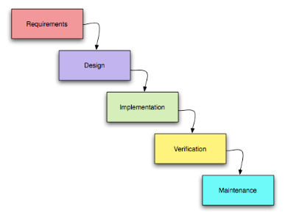

**V-Shaped Model:** This model, also known as the Verification and Validation model, is an extension of the Waterfall model based on a testing phase (also known as Verification and Validation) for each development stage. Like the Waterfall model work can only move on to the next phase after completion of the previous so therefore is a very rigid and linear approach to software development. In order to be successful, it requires a highly disciplined approach with thorough design, development and documentation.

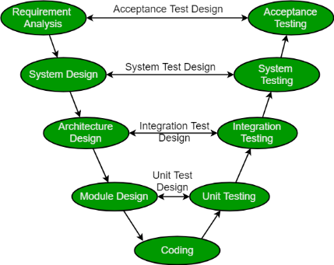

**Rapid Application Model (RAD):** The RAD model favours early prototyping and iterative delivery making it well suited to software development. Its unlike the previous methods in that is a malleable form of development meaning making changes can be implemented quickly and easily. By prototyping early a build can be tested by the client in order to garner feedback that can be used to steer a project in a direction to meet the clients need fully. By implementing iterative design a project is more likely to be completed within budget and on time by mitigating the chance of catastrophic failure that can occur when using the Waterfall method. This model lacks scalability meaning it would be unsuited to large projects.

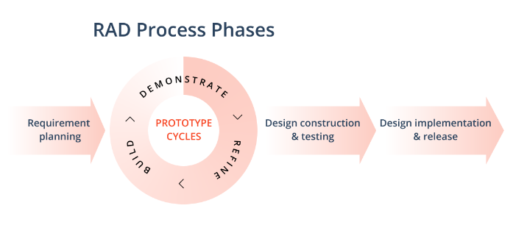

**Spiral Model:** A Spiral model is a risk-driven software development model. It is a combination of Waterfall and Iterative models. Each phase begins with a design goal and ends in client review. It begins with a small set of requirements and goes through each development phase for those requirements. Increasing requirements and functionality is added in ever increasing spirals until the project is complete. It is great for large scale projects where risk and cost evaluation are major factors however it requires skilled risk assessment and a strict adherence to the Spiral model protocol in order to work.

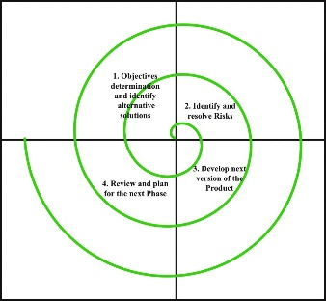

**Agile Model:** The agile model is a combination of iterative and incremental models with a focus on adaptability and customer satisfaction. Each iteration lasts a short time, and every iteration involves cross functional teams working simultaneously. After each iteration, a working build is delivered, and each iteration is incremental in features with the final build having all the features required by the client. As well as being an easy to manage and flexible model it doesn’t require a lot of resources and can help strengthen the team with its focus on teamwork and cross training. However, it is vital that good communication with the client in order to ensure the team isn’t driven in the wrong direction.

